Shengyang Guan Final Project

MIS 370

Dr. Grant

May 28, 2018

Table of Contents

Content Page Title 1

Table of Contents 2

SQL CODE FOR EACH QUERY 3

Reasons for Report 7

Query Reports 8

Relational Schema 14

Relational Diagram 15

3NF 16

ERD 19

**SQL CODE FOR EACH QUERY**

CREATE TABLE CLIENT

(CLIENT_NUM CHAR(4) NOT NULL,

CLIENT_FNAME varchar(10),

CLIENT_Int varchar(10),

CLIENT_LNAME varchar(10),

CLIENT_REGION varchar(10),

PRIMARY KEY(CLIENT_NUM));

Drop TABLE CONTRACT

CREATE TABLE CONTRACT

(CONTRACT_NUMBER CHAR(4) NOT NULL,

CLIENT_NUM CHAR(4) NOT NULL,

CONTRACT_DATE DATETIME,

CONTRACT_AMOUNT MONEY,

CONSULT_CLASS_1 varchar(30),

CONSULT_CLASS_2 varchar(30),

CONSULT_CLASS_3 varchar(30),

CONSULT_CLASS_4 varchar(30),

CONSULTANT_NUM_1 CHAR(4) NOT NULL,

CONSULTANT_NUM_2 CHAR(4) NOT NULL,

CONSULTANT_NUM_3 CHAR(4) NOT NULL,

CONSULTANT_NUM_4 CHAR(4) NOT NULL,

PRIMARY KEY(CONTRACT_NUMBER));

CREATE TABLE CONSULTANT

(CONSULTANT_NUM CHAR(4) NOT NULL,

CONSULTANT_FNAME varchar(10),

CONSULTANT_INT varchar(10),

CONSULTANT_LNAME

varchar(10),

CONSULTANT_REGION varchar(10),

CONSULTANT_CLASS_1 varchar(30),

CONSULTANT_CLASS_2 varchar(30),

CONSULTANT_CLASS_3 varchar(30),

CONSULTANT_CLASS_4 varchar(30),

PRIMARY KEY(CONSULTANT_NUM));

insert into CLIENT values('289','Marianne','R.','Brown','Midwest');

insert into CLIENT values('298','James','D.','Smith','Southeast');

insert into CLIENT values('299','Gerald','A.','Gallega','Midwest');

insert into CLIENT values('300','Alice','B.','VanderVoort','West');

insert into CLIENT values('301','Willaker','C.','Mary','West');

insert into CLIENT values('302','Jill','D.','Martin','Southeast');

insert into CLIENT values('303','Gerald','A.','Martin','Midwest');

insert into CLIENT values('304','Hank','B.','Jones','Southeast');

insert into CLIENT values('305','JoAnne','C.','Rightonit','Midwest');

insert into CLIENT values('306','McGuire','D.','Bryana','West');

insert into CLIENT values('307','George','A.','Brown','West');

insert into CONTRACT values('5841','298','10-Feb-2008','$2,985,000.00','Database Administration','Web Applications',' ',' ','29','56','22',' ');

insert into CONTRACT values('5842','289','15-Feb-2008','$670,300.00','Internet Servies',' ',' ',' ','34','38','45','18');

insert into CONTRACT values('5843','289','12-Feb-2008','$1,250,000.00','Database Design','Database Administration','Network Installation',' ','25','34',' ',' ');

insert into CONTRACT values('5844','300','11-Feb-2008','$3,250,000.00','Internet Servies','Network Installation',' ',' ','22','29',' ',' ');

insert into CONTRACT values('5845','301','12-Oct-2008','$650,300.00','Network Installation','Web Applications',' ',' ','34','56',' ',' ');

insert into CONTRACT values('5846','301','12-Dec-2008','$2,988,000.00','Database Administration','Database Design',' ',' ','18',' ',' ',' ');

insert into CONTRACT values('5847','307','5-Oct-2008','$6,023,300.00','Database Administration','Web Applications',' ',' ','26','28','34','29');

insert into CONTRACT values('5848','308','2-Aug-2008','$3,085,000.00','Internet Servies',' ',' ',' ','25','27',' ',' ');

insert into CONTRACT values('5849','302','24-Jul-2008','$2,670,300.00','Database Design','Database Administration','Network Installation',' ','34','22',' ',' ');

insert into CONTRACT values('5850','304','30-Oct-2008','$22,250,000.00','Network Installation',' ',' ',' ','45','56',' ',' ');

insert into CONTRACT values('5851','304','15-Jun-2008','$870,300.00','Database Design','Web Applications',' ',' ','38',' ',' ',' ');

insert into CONSULTANT values('29','Rachel','G.','Carson','Midwest','Internet Servies','Database Administration',' ',' ');

insert into CONSULTANT values('56','Karl','M.','Spenser','Midwest','Database Administration','Web Applications',' ',' ');

insert into CONSULTANT values('22','Julian','H.','Donatello','Midwest','Database Design',' ',' ',' ');

insert into CONSULTANT values('34','Gerald','K.','Ricardo','Southeast','Network Installation','Database Administration',' ',' ');

insert into CONSULTANT values('38','Anne','T.','Dimarco','Southeast','Internet Servies','Network Installation',' ',' ');

insert into CONSULTANT values('45','Geraldo','J.','Rivera','Southeast','Network Installation','Web Applications',' ',' ');

insert into CONSULTANT values('18','Donald',' ','Chen','West','Database Administration','Database Design','Network Installation',' ');

insert into CONSULTANT values('25','Angela','M.','Jamison','Southeast','Database Administration','Web Applications',' ',' ');

insert into CONSULTANT values('26','JoAnne','A.','Martin','Midwest','Internet Servies','Web Applications',' ',' ');

insert into CONSULTANT values('28','Alice','S.','VanderVoort','Southeast','Database Design',' ',' ',' ');

insert into CONSULTANT values('27','James',' ','Brown','West','Network Installation','Database Design',' ',' ');

**Reasons for Report**

1. Showing the number of customers by region, so that marketing manager could make strategy base on region.
2. Showing the active consultants that decide promotion or demotion them.
3. Showing the contact total price of all region, so that manager could know how much profit the company make.
4. Showing the all consultants of all region, so that manager could sent trained consultants to where lack of consultants.
5. Listing the consultants has same classifications that manager know the strengths of classifications.
6. Listing the first name and last name of all client who has more than one contact. Consider them as VIP clients.
7. Showing all consultants and their location, so that we can assign them to same location client.
8. Listing all contracts sign in the first season and the price. Company can decide strategy for next year.
9. Showing consultants who has more than two special classifications and included 'Database Administration' to find the skillful consultants.
10. Listing all client and their information that we can assign new contract to fit them needs.

**10 Query Reports**

1.SELECT  CLIENT_FNAME,CLIENT_LNAME,CLIENT_REGION

FROM CLIENT

ORDER BY CLIENT_REGION ASC

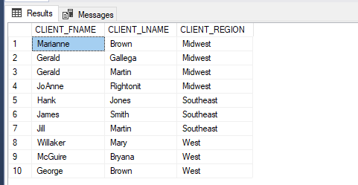

2.SELECT CONSULTANT_FNAME,CONSULTANT_LNAME,CONSULTANT_NUM

FROM CONSULTANT

WHERE EXISTS(SELECT * FROM CONTRACT WHERE CONSULTANT_NUM=CONSULTANT_NUM_1 OR CONSULTANT_NUM=CONSULTANT_NUM_2 OR CONSULTANT_NUM=CONSULTANT_NUM_3 OR CONSULTANT_NUM=CONSULTANT_NUM_4)

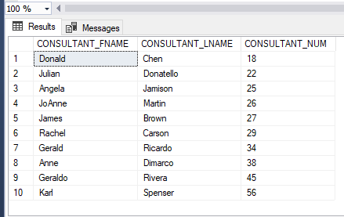

3.SELECT SUM(CONTRACT_AMOUNT)AS TOTALprofit

FROM CONTRACT

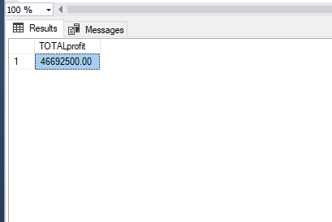

4.SELECT CONSULTANT_FNAME,CONSULTANT_LNAME,CONSULTANT_REGION

FROM CONSULTANT

ORDER BY CONSULTANT_REGION ASC

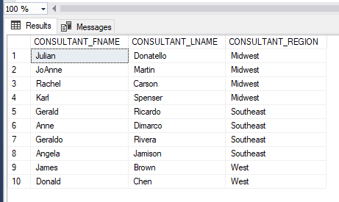

5.SELECT CONSULTANT_FNAME,CONSULTANT_LNAME,CONSULTANT_CLASS_1,CONSULTANT_CLASS_2,CONSULTANT_CLASS_3,CONSULTANT_CLASS_4

FROM CONSULTANT

ORDER BY CONSULTANT_CLASS_1,CONSULTANT_CLASS_2,CONSULTANT_CLASS_3,CONSULTANT_CLASS_4 ASC

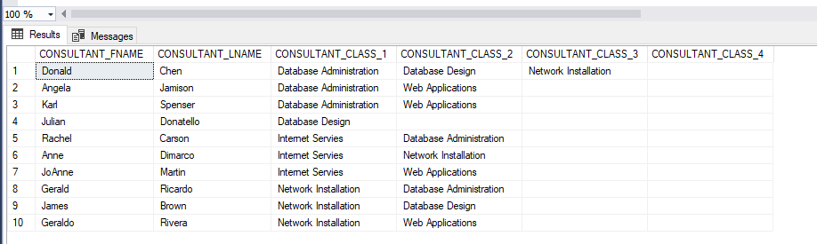

6.SELECT  CLIENT_FNAME,CLIENT_LNAME,CLIENT_REGION

FROM CLIENT CLIENT_NUM

WHERE EXISTS (SELECT *

                 FROM CONTRACT CLIENT_NUM

                 WHERE CLIENT_NUM=CLIENT_NUM HAVING count(*) > 1);

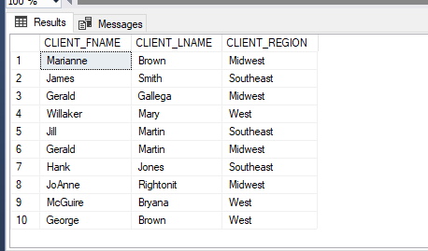

7.SELECT  CONSULTANT_NUM,CONSULTANT_FNAME,CONSULTANT_INT,CONSULTANT_LNAME,CONSULTANT_REGION

FROM CONSULTANT

ORDER BY CONSULTANT_REGION ASC

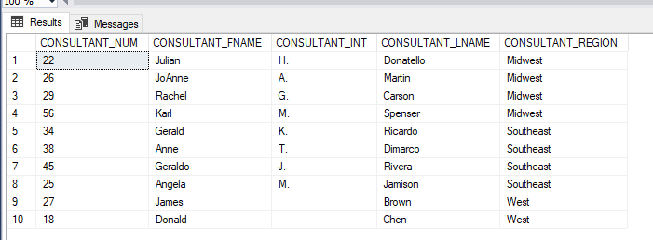

8.SELECT  CONTRACT_NUMBER,CONTRACT_DATE,CONTRACT_AMOUNT

FROM CONTRACT

WHERE CONTRACT_DATE<='2008-03-01'

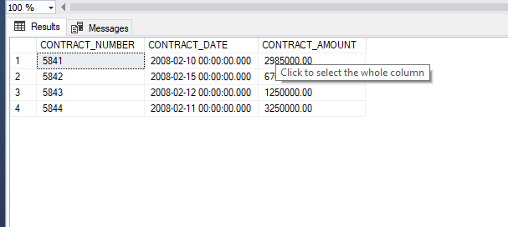

9.SELECT  CONSULTANT_FNAME,CONSULTANT_LNAME,CONSULTANT_CLASS_1,CONSULTANT_CLASS_2,CONSULTANT_CLASS_3,CONSULTANT_CLASS_4

FROM CONSULTANT

WHERE CONSULTANT_CLASS_1='Database Administration' OR CONSULTANT_CLASS_2='Database Administration'

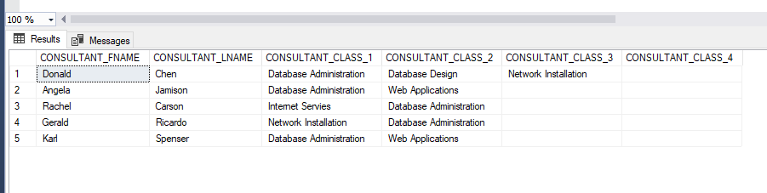

10.SELECT  CLIENT_NUM,CLIENT_FNAME,CLIENT_Int,CLIENT_LNAME,CLIENT_REGION

FROM CLIENT

ORDER BY CLIENT_NUM ASC

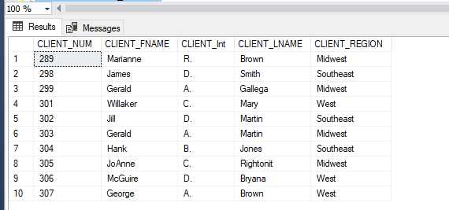

**Relational Schema**

CLIENT

CLIENT_NUM,CLIENT_FNAME,CLIENT_Int,CLIENT_LNAME,CLIENT_REGION

CONTRACT

CONTRACT_NUMBER,CLIENT_NUM,CONTRACT_DATE,CONTRACT_AMOUNT,

CONSULT_CLASS_1,CONSULT_CLASS_2,

CONSULT_CLASS_3,CONSULT_CLASS_4,

CONSULTANT_NUM_1,CONSULTANT_NUM_2,

CONSULTANT_NUM_3,CONSULTANT_NUM_4,

CONSULTANT

CONSULTANT_NUM,CONSULTANT_FNAME CONSULTANT_INT, CONSULTANT_LNAME, CONSULTANT_REGION, CONSULTANT_CLASS_1, CONSULTANT_CLASS_2,CONSULTANT_CLASS_3, CONSULTANT_CLASS_4

**Relational Diagram**

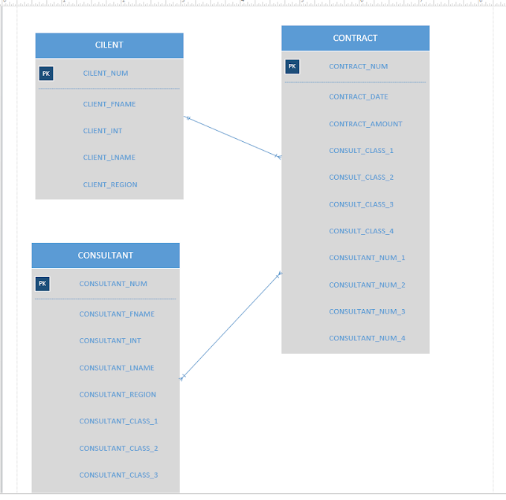

**3NF**

Table CONSULTANT

|  |  |  |  |  |  |  |  |  |
| --- | --- | --- | --- | --- | --- | --- | --- | --- |
| CONSULTANT_NUM | CONSULTANT_FNAME | CONSULTANT_INT | CONSULTANT_LNAME | CONSULTANT_REGION | CONSULTANT_CLASS_1 | CONSULTANT_CLASS_2 | CONSULTANT_CLASS_3 | CONSULTANT_CLASS_4 |
| 29 | Rachel | G. | Carson | Midwest | Internet Servies | Database Administration |  |  |
| 56 | Karl | M. | Spenser | Midwest | Database Administration | Web Applications |  |  |
| 22 | Julian | H. | Donatello | Midwest | Database Design |  |  |  |
| 34 | Gerald | K. | Ricardo | Southeast | Network Installation | Database Administration |  |  |
| 38 | Anne | T. | Dimarco | Southeast | Internet Servies | Network Installation |  |  |
| 45 | Geraldo | J. | Rivera | Southeast | Network Installation | Web Applications |  |  |
| 18 | Donald |  | Chen | West | Database Administration | Database Design | Network Installation |  |
| 25 | Angela | M. | Jamison | Southeast | Database Administration | Web Applications |  |  |
| 26 | JoAnne | A. | Martin | Midwest | Internet Servies | Web Applications |  |  |
| 28 | Alice | S. | VanderVoort | Southeast | Database Design |  |  |  |
| 27 | James |  | Brown | West | Network Installation | Database Design |  |  |

Table CLIENT

|  |  |  |  |  |
| --- | --- | --- | --- | --- |
| CLIENT_NUM | CLIENT_FNAME | CLIENT_Int | CLIENT_LNAME | CLIENT_REGION |
| 289 | Marianne | R. | Brown | Midwest |
| 298 | James | D. | Smith | Southeast |
| 299 | Gerald | A. | Gallega | Midwest |
| 300 | Alice | B. | VanderVoort | West |
| 301 | Willaker | C. | Mary | West |
| 302 | Jill | D. | Martin | Southeast |
| 303 | Gerald | A. | Martin | Midwest |
| 304 | Hank | B. | Jones | Southeast |
| 305 | JoAnne | C. | Rightonit | Midwest |
| 306 | McGuire | D. | Bryana | West |
| 307 | George | A. | Brown | West |

TABLE CONTRACT

|  |  |  |  |  |  |  |  |  |  |  |  |
| --- | --- | --- | --- | --- | --- | --- | --- | --- | --- | --- | --- |
| CONTRACT_NUMBER | CLIENT_NUM | CONTRACT_DATE | CONTRACT_AMOUNT | CONSULT_CLASS_1 | CONSULT_CLASS_2 | CONSULT_CLASS_3 | CONSULT_CLASS_4 | CONSULTANT_NUM_1 | CONSULTANT_NUM_2 | CONSULTANT_NUM_3 | CONSULTANT_NUM_4 |
| 5841 | 298 | 10-Feb-2008 | $2,985,000.00 | Database Administration | Web Applications |  |  | 29 | 56 | 22 |  |
| 5842 | 289 | 15-Feb-2008 | $670,300.00 | Internet Servies |  |  |  | 34 | 38 | 45 | 18 |
| 5843 | 289 | 12-Feb-2008 | $1,250,000.00 | Database Design | Database Administration | Network Installation |  | 25 | 34 |  |  |
| 5844 | 300 | 11-Feb-2008 | $3,250,000.00 | Internet Servies | Network Installation |  |  | 22 | 29 |  |  |
| 5845 | 301 | 12-Oct-2008 | $650,300.00 | Network Installation | Web Applications |  |  | 34 | 56 |  |  |
| 5846 | 301 | 12-Dec-2008 | $2,988,000.00 | Database Administration | Database Design |  |  | 18 |  |  |  |
| 5847 | 307 | 5-Oct-2008 | $6,023,300.00 | Database Administration | Web Applications |  |  | 26 | 28 | 34 | 29 |
| 5848 | 308 | 2-Aug-2008 | $3,085,000.00 | Internet Servies |  |  |  | 25 | 27 |  |  |
| 5849 | 302 | 24-Jul-2008 | $2,670,300.00 | Database Design | Database Administration | Network Installation |  | 34 | 22 |  |  |
| 5850 | 304 | 30-Oct-2008 | $22,250,000.00 | Network Installation |  |  |  | 45 | 56 |  |  |
| 5851 | 304 | 15-Jun-2008 | $870,300.00 | Database Design | Web Applications |  |  | 38 |  |  |  |

**Entity Relationship Diagram**

